Sales Quotation
Comment:
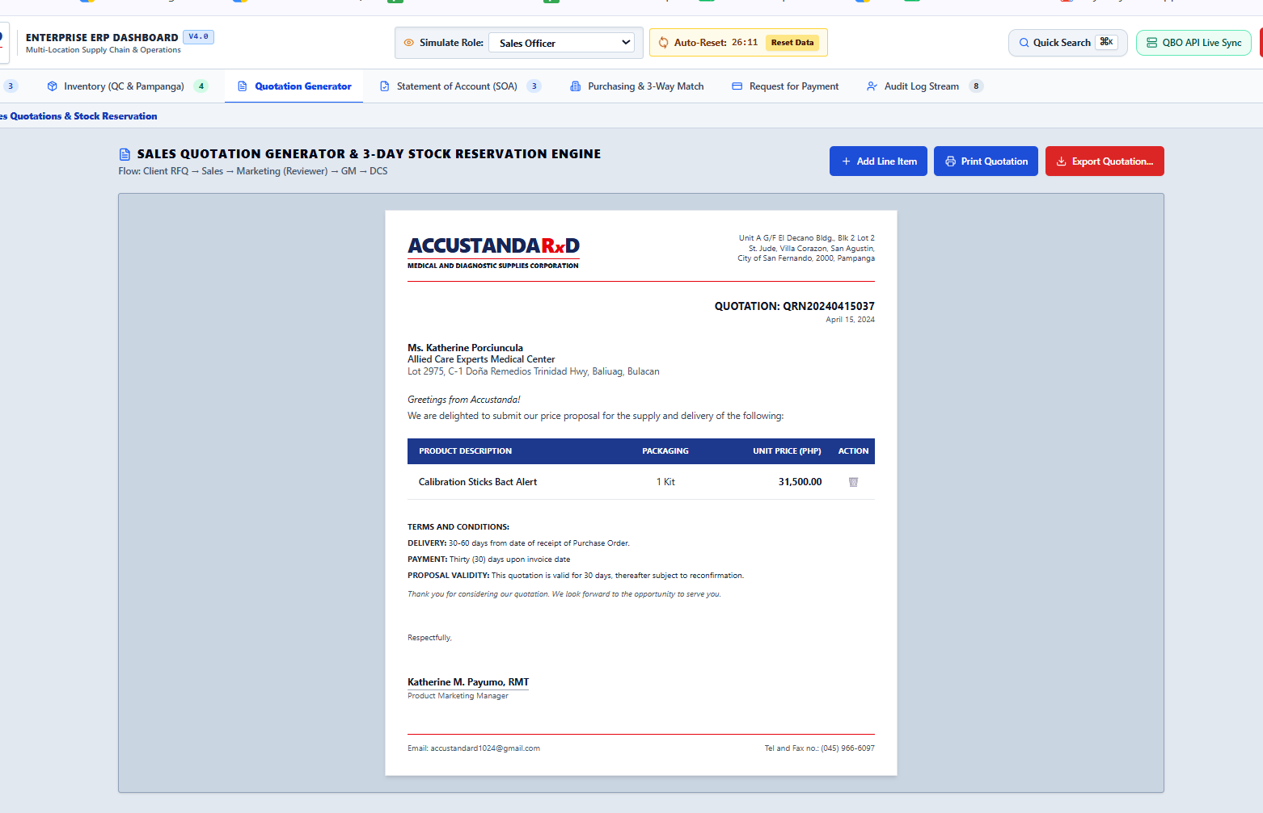
No create or request sales quote. No submit for approval.

Purchasing and receiving
Comment: no access for warehouse. Sya dapat ang may access on here. Sya din kasi dapat ang maglalagay kung ilan nareceive

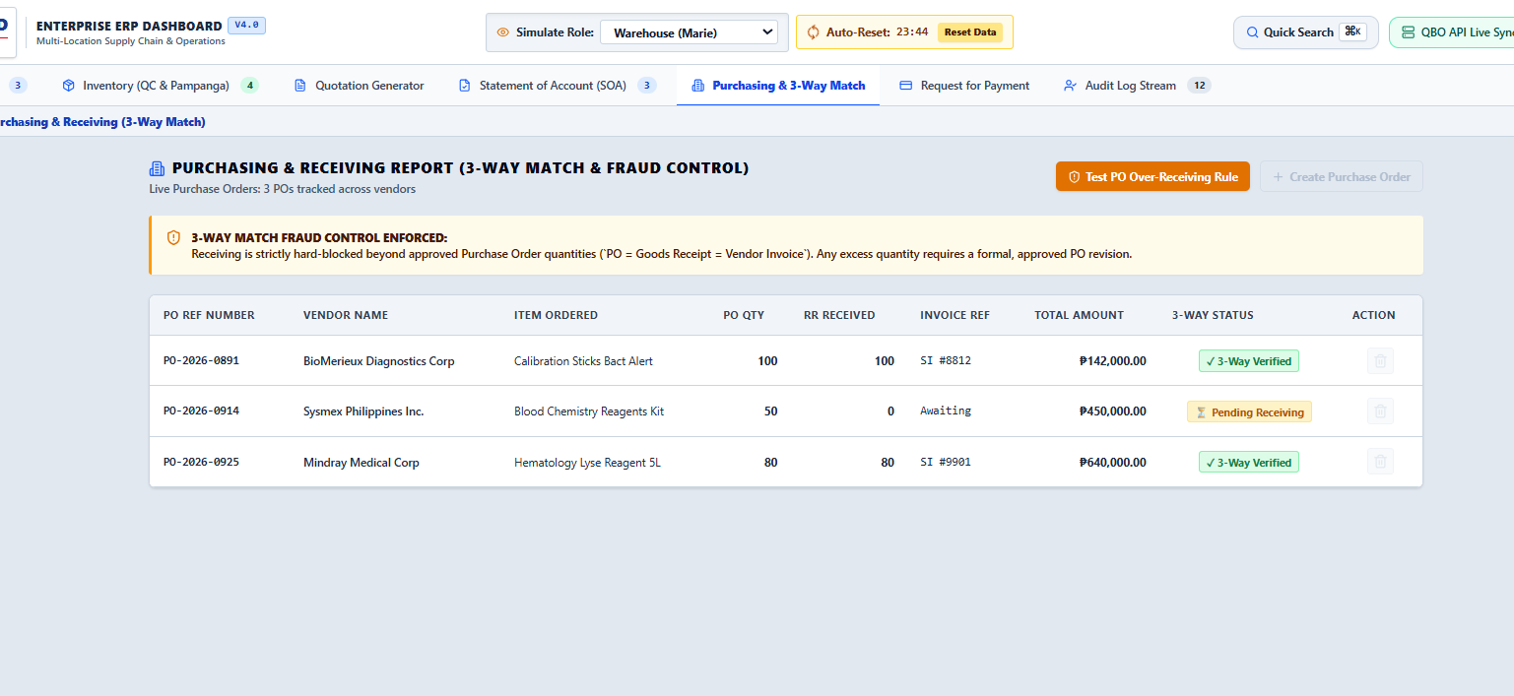

Bookkeeper ang may access dito. Dapat warehouse. Also pwede bang lagyan ng dropdown for inventory items.
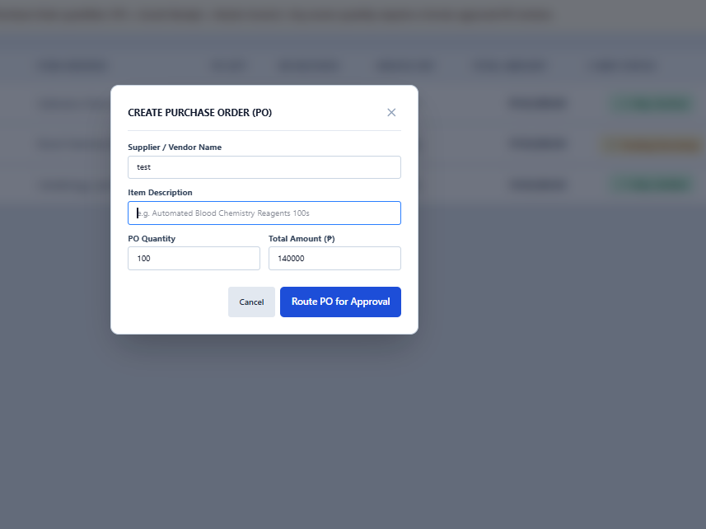
Yung dropdown ng PO dapat naka maintain or registered dito
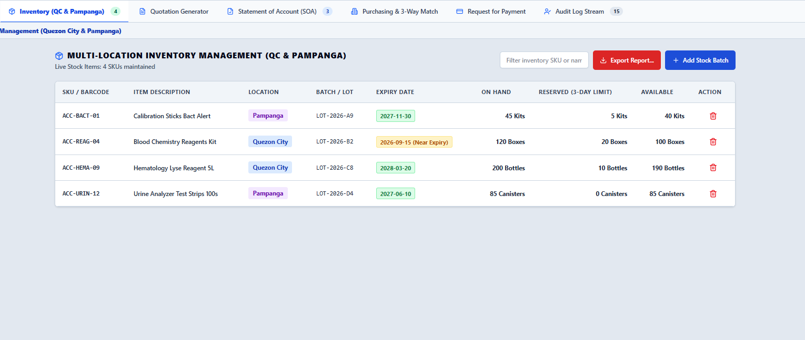

Admin View
Daming wala pa. Dapat may setup dito ng Users, and yung allowed view nila.

